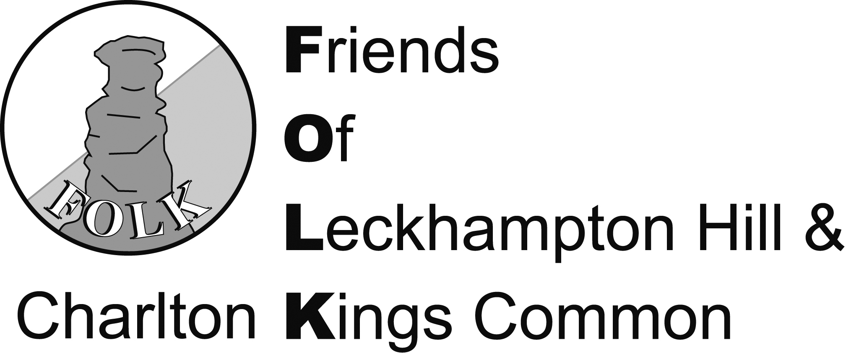

Minutes of the Seventeenth Annual General Meeting
held on Wednesday 9th November 2016 at Leckhampton Primary School

17.0 Welcome
The Chair, John Harvey, welcomed about 35 members and visitors to the Seventeenth AGM of FOLK.
17.1 Apologies for Absence
Paul Baker, Margaret Patterson, Wendy Freedman, Jane Kirby, Jack Shepherd, Jill Sheperd, Jenny Palmer
17.2 Minutes of the Sixteenth AGM Held on 11th November 2015
The minutes of the sixteenth AGM were accepted and signed as a true record of the meeting.
Proposed: Mike Donnelly
Seconded: Pete Niblett

17.3 Matters Arising
There were no matters arising.
17.4 Annual Report
The chairman explained that FOLK had produced an Annual Report for the year ending 30th Sept 2016. This report includes all the reports from officers of FOLK. A copy of the report is attached to these minutes as appendix. The chairman went through the annual report and the following additional comments were made by the appropriate FOLK officers.
17.4.1. The three newsletters produced during the year were the singlehanded work of Peter Whalley. The newsletters are always interesting and informative and are much appreciated by the members. Several members at the meeting endorsed this. The chairman thanked Peter or his valuable work on the newsletters.
17.4.2 The spring lecture given by Dr Ray Wilson was extremely well attended and much appreciated by those who attended. This event was organised by Mike Donnelly, and the chairman thanked him for this.
17.4.3. The chairman drew attention to the much improved FOLK website. Geoff Holt had lead the work on developing this website over the previous year and the chairman thanked him for this.
17.4.4. The annual report provided an analysis of the volunteer hours delivered by FOLK over the past year, but also stressed that this did not take account of much further work that had not been quantified. Several members emphasised the considerable value of this work and encouraged FOLK to try and include all the hours of work done in future reports. This could be of significant value when reporting to potential donors in the future.
17.4.5. The membership numbers showed a steady but unspectacular increase over the past year and once again FOLK will seek to expand its membership during the coming year.
17.4.6. Geoff Holt explained that the work parties had continued throughout the year working to the plans produced for each successive 6 month period (these are published on the FOLK website). Peter Whalley commented that Natural England had inspected the site during the year and were pleased with the work done. They had also expressed interest in possibly surveying for the presence of Adders in the year ahead.
17.4.7. The Treasurer presented the Financial Report and concluded that the finances of FOLK were in a healthy state.

Acceptance of the Annual Report (including the accounts) was proposed by Paul Ryder and seconded by Serena Meredith.

17.5 Motions for Discussion
The Chairman explained that he would welcome the members views on whether FOLK should be involved in responding to planning applications and what should be FOLK’s priorities for the year ahead.
17.5.1 Planning: The Chairman explained that the current constitution of FOLK did not have any reference to FOLK’s possible involvement in planning applications that might impact the Hill or Common. He asked whether FOLK should be involved in such applications and if so should the constitution of FOLK be amended to specifically refer to this. The Chairman had previously written an article for the FOLK newsletter on this subject and invited comment, but had received none. There then ensued a lively discussion on the topic. A representative of LEGLAG explained that they were actively involved in the planning process relating to the fields that can be viewed from Leckhampton Hill and he would welcome FOLK’s support in this activity. However, several members expressed the view that FOLK does good work relating to conservation and improvement on the Hill and Common and it would be better to stick to that rather than become involved in lobbying activities. The widespread view seemed to be that the constitution should not be amended and FOLK should confine itself to its current activities.
17.5.2 Priorities for 2017. The Chairman invited comments on what FOLK should prioritise in the year ahead.
Paul Ryder commented that he would welcome the installation of more bird boxes on the site and an increased focus on encouraging wildlife.
A representative from LEGLAG commented that they would be willing to circulate their
1000+ members on topics that may be of common interest between FOLK and LEGLAG.
The Chairman explained that he would also like to increase the focus on Archaeology during the year ahead and include this in the work currently underway on mapping of the Hill and Common.

17.6 Election of Officers and Executive Committee Members
17.6.1 Election of Officers
The Secretary reported the situation as regards vacancies.
The Chair, Treasurer and Secretary may stand for election annually for a maximum of 5, 4 & 3 years respectively.

Chair, John Harvey is eligible and willing to stand for a further year.
There being no other nominees, John Harvey therefore continues as Chair.

Treasurer, Geoff Holt has served his permitted time of 4 years and is not eligible to stand as Treasurer. A nomination had been received for Malcolm Geddes to stand as Treasuer (nominated by Geoff Holt). This was seconded by Andrew Ross. There being no other nominations, Malcolm Geddes was appointed as Treasurer. The constitution allows Geoff Holt to be automatically co opted as a committee member for a further year, and Geoff has accepted this.

Secretary, Andrew Ross is eligible and willing to stand for a further year. There being no other nominees, Andrew Ross continues as Secretary.

The meeting approved these decisions.

17.6.2. Election of Executive Committee Members
The Secretary led the meeting through this item.
Committee Members are elected to serve for a term of 3 years, and can be re-elected for a second term of 3 years.
There are now 3 vacancies, and we have 1 nomination:
Chris Ryder (for a second term)
There being no other nominees, Chris Ryder is elected to the committee.

Other elected members continuing on the committee are: David Browning, Anne North, Peter Whalley, Julius Marstrand, Alistair Mckenzie, Peter Niblett.

The meeting approved these decisions.

The Chair thanked the departing members of the Exec for their work during their term on the Exec

17.7 Any Other Business
17.7.1 Life Members: The Chairman explained the constitution of FOLK allowed for the creation of up to 10 Honorary Life Members. These memberships are awarded to individuals who have made a substantial contribution to the work of FOLK. Life members are nominated by the Exec Committee and elected at a general meeting. This year the Exec Committee has nominated two individuals to receive Honorary Life Membership in recognition of their outstanding work on the work parties over a number of years. The two members nominated to receive Life Membership are Malcolm Geddes and Tony Childs. Peter Niblett described the enthusiastic work done by Malcolm and Tony over a long period and without any regard to their advancing years. The general meeting agreed unanimously to these nominations. The Chairman presented Malcolm Geddes with a letter from the Mayor of Cheltenham (Chris Ryder) thanking him for his dedicated support of FOLK. Tony was not present at the AGM, but a similar letter from the Mayor will be delivered to Tony

There was no other business so the formal AGM closed at around 8.00 pm, followed by an interesting, talk by Toby Catchpole on the Archaeology of Leckhampton Hill and the surrounding area.

Signed: .................................................................. Chair

.................................................................. Secretary

Date: ....................................

